Prerequisit for the installation of Jenkins

1. Java 1.5 or higher
2. Java in your path (optional but preferred)
3. Web server (Only if you want to host outside of jenkins)

Issues faced during the installation of the Jenkins

Download Jenkins war for server installation

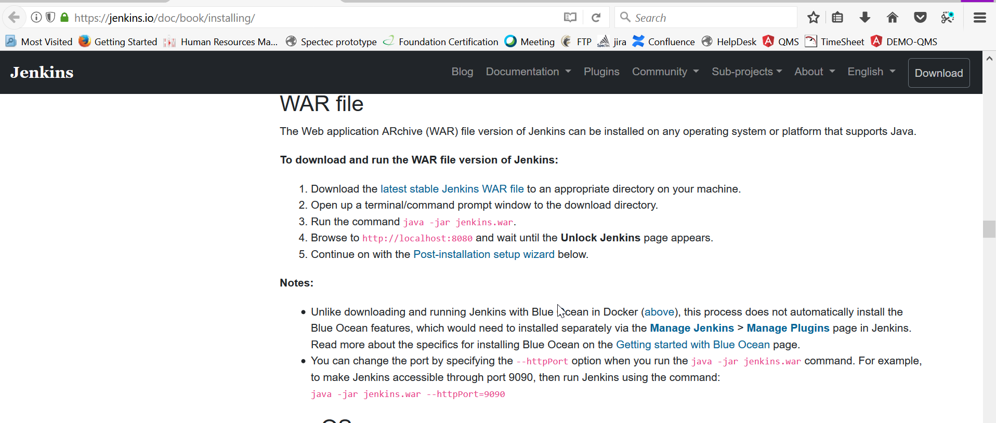

<https://jenkins.io/doc/book/installing/>

search the keyword ”l[atest stable Jenkins WAR file](http://mirrors.jenkins.io/war-stable/latest/jenkins.war)”

Running from: C:\Program Files\Jenkins\jenkins.war

webroot: EnvVars.masterEnvVars.get("JENKINS_HOME")

[Winstone 2012/05/17 10:14:42] - Beginning extraction from war file

Jenkins home directory: C:\Program Files\Jenkins found at: EnvVars.masterEnvVars.get("JENKINS_HOME")

[Winstone 2012/05/17 10:14:44] - Winstone shutdown successfully

[Winstone 2012/05/17 10:14:44] - Container startup failed

java.io.IOException: Failed to start a listener: winstone.HttpListener

at winstone.Launcher.spawnListener(Launcher.java:250)

at winstone.Launcher.<init>(Launcher.java:202)

at winstone.Launcher.main(Launcher.java:398)

at sun.reflect.NativeMethodAccessorImpl.invoke0(Native Method)

at sun.reflect.NativeMethodAccessorImpl.invoke(Unknown Source)

at sun.reflect.DelegatingMethodAccessorImpl.invoke(Unknown Source)

at java.lang.reflect.Method.invoke(Unknown Source)

at Main._main(Main.java:268)

at Main.main(Main.java:96)

Caused by: java.io.IOException: Failed to listen on port 8080

at winstone.HttpListener.getServerSocket(HttpListener.java:117)

at winstone.HttpListener.start(HttpListener.java:70)

at winstone.Launcher.spawnListener(Launcher.java:241)

... 8 more

Caused by: java.net.BindException: Address already in use: JVM_Bind

at java.net.PlainSocketImpl.socketBind(Native Method)

at java.net.PlainSocketImpl.bind(Unknown Source)

at java.net.ServerSocket.bind(Unknown Source)

at java.net.ServerSocket.<init>(Unknown Source)

at java.net.ServerSocket.<init>(Unknown Source)

at winstone.HttpListener.getServerSocket(HttpListener.java:112)

Solution:

Execute the command from command prompt

java -jar jenkins.war --httpPort=8081